Phone: (605) 763-5096 Fax: (605) 763-2206
Website: http://sp.gayvillevolin.k12.sd.us/sildl Email: jason.selchert@k12.sd.us
Agenda
SILDL Board of Directors
December 18. 2013
Mount Marty Campus
5001 W. 41st Street
Sioux Falls, SD 57106

Call to Order (11:00 am)
Approve Minutes of Last Meeting
Financial Report
- Approve Bills – Cheryl Motion___________ Second_______________ Vote___________
Approve Agenda
Motion ____________Second________________Vote____________
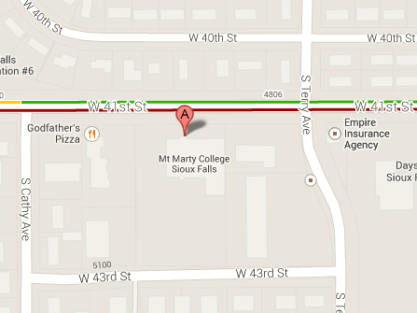
Reports
- Bonnie Overweg
- Jason Selchert
Discussion/Action
- Update Schedule
- High School Classes
- Enrollment Information
Adjournment
Next Meeting: January 15, 2013 (Holiday Inn Downtown)

